**JAYPEE INSTITUTE**

**OF INFORMATION**

**TECHNOLOGY**

**ALGORITHMS AND PROBLEM SOLVING**

**PROJECT:-CUSTOMISED TRAVEL PLANNER MANAGEMENT**

**GROUP MEMBERS:-**

|  |  |  |
| --- | --- | --- |
| NAME | ENROLLMENT NUMBER | BATCH |
| STUTI SHARMA | **20103106** | **B4** |
| DEVIKA GUPTA | **20103115** | **B4** |
| AARUSHEE KRISHNA | **20103120** | **B4** |
| MITUL JAIN | **20103103** | **B4** |

**SUBMITTED TO FACULTY-DR. SUMA DAWN**

**CERTIFICATE**

This is to certify that Stuti Sharma, Devika Gupta ,Aarushee Krishna and Mitul Jain of B-Tech, Second year from CSE Branch of Batch B4 have successfully created the project on the topic “Customized Travel Planner Management System” under the guidance of Dr. Suma Dawn .

**Dr. SUMA DAWN**

**(Lab Faculty)**

Date of submission: 26-05-2022

**ACKNOWLEDGEMENT**

Every successful venture has the blessing and the support of many behind it. It would be unjust if every such support is not revealed and thanked in person. If words were considered as a symbol of approval and a token of appreciation then let the words play the heralding role expressing our gratitude.

We would like to place on record our deep sense of gratitude to Dr. Suma Dawn Ma’am for giving us an opportunity to work together and her constant guidance throughout the project. Also, we would like to thank Mrs. Shikha Jain ma’am for her support and guidance.

Finally, an honorable mention goes to our friends and family for their support to do this project. Without help of the particulars mentioned above, we would have faced many difficulties while pursuing this project.

**INTRODUCTION**

The topic chosen by our group for the subject ‘Algorithm’ is Customized travel planner. We have decided to make a menu driven program to implement a travel planner that will cater the need of the customer to make a wise decision about the planned journey.

Our program will firstly ask the user about the starting city and the destination city. Then according to the database, the program will search for the shortest path available between the cities via different means of transportation, i.e., cabs, buses, flights, personal vehicle, train etc.

This will be achieved by Dijkstra’s algorithm and finding the Hamiltonian path.

If a suitable path is found between the two cities, then we ask user about their traveling effectiveness. Whether they want their trip to be cost effective or time effective.

The program will then fetch the required alternatives available from the database.

For e.g., if the user selects a time effective travel plan, then the program will display the details of all the transport that takes a lesser amount of time to reach the destination like superspeed express, or flights (if any). On selecting the cost-effective alternative, the user will be asked to input the planned budget, to further narrow down the alternatives. When the user selects a desired option from the results. He/she is prompted to enter the details of the traveling passengers and the weight of the luggage planned to be taken along with the passengers in the journey.

If the constraints of the selected transportation facility match with the entered values of luggage and passengers, then the booking is considered to be final and the travel itinerary along with travel ticket is generated by the program.

If the constraints of the selected transportation facility do not match with the entered value of luggage and passengers, then the booking is cancelled and the program returns the control to the travel alternatives which gives the user option to again select a new transportation option which will match his/her needs.

The program will run till the user finds an optimized travel plan according to his/her needs with customized options for the number of people traveling and the weight of the luggage.

The user will then be given a unique booking ID number which will be generated using the Huffman encoding algorithm. The program will ask for the name of the user and encode it to represent that user uniquely.

Hence our project will be an optimization problem which will aid the users to find the budget friendly transportation option according to their needs.

**ALGORITHMS USED**

In our project we have applied: -

* Dijkstra’s algorithm- We have applied this algorithm to find out the shortest path between two stations from the txt file. The usage of this code can be seen below: -

void dijkstra(float graph[V][V], int src, int targ, int inter)

{

float distance[V];

bool visited[V];

for (int i = 0; i < V; i++)

{

distance[i] = INT_MAX;

visited[i] = false;

}

distance[src] = 0;

for (int count = 0; count < V - 1; count++)

{

int u = distance_min(distance, visited);

visited[u] = true;

for (int v = 0; v < V; v++)

{

if (!visited[v] && graph[u][v] && distance[u] != INT_MAX && distance[u] + graph[u][v] < distance[v])

{

distance[v] = distance[u] + graph[u][v];

compute[r][0] = v;

compute[r][1] = u;

r++;

P[v].p.push_back(u);

}

}

}

Path(distance[targ], targ, src, inter);

}

* Huffman encoding- We have applied this algorithm to generate the unique booking ID of the customer and have displayed it on the ticket generated at the end of the transaction.

void huffmanCoding(string str)

{

priority_queue<node> qu;

int frequency[256];

for (int i = 0; i < 256; i++)

frequency[i] = 0;

for (int i = 0; i < str.size(); i++)

{

frequency[int(str[i])]++;

}

for (int i = 0; i < 256; i++)

{

if (frequency[i])

{

qu.push(node(i, frequency[i]));

}

}

while (qu.size() > 1)

{

node *c0 = new node(qu.top());

qu.pop();

node *c1 = new node(qu.top());

qu.pop();

qu.push(node(c0, c1));

}

cout <<endl<<"\t\t TICKET ID : ";

qu.top().traverse();

}

**FLOW CHART**

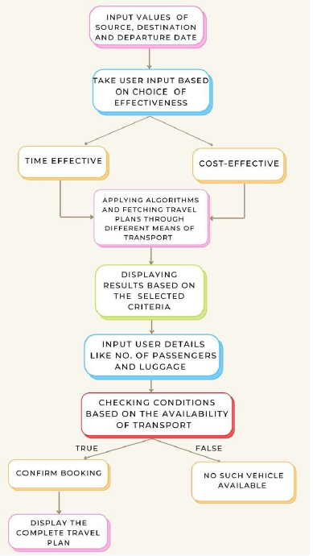

**OUTPUT SCREENSHOTS**

* MAIN SCREEN

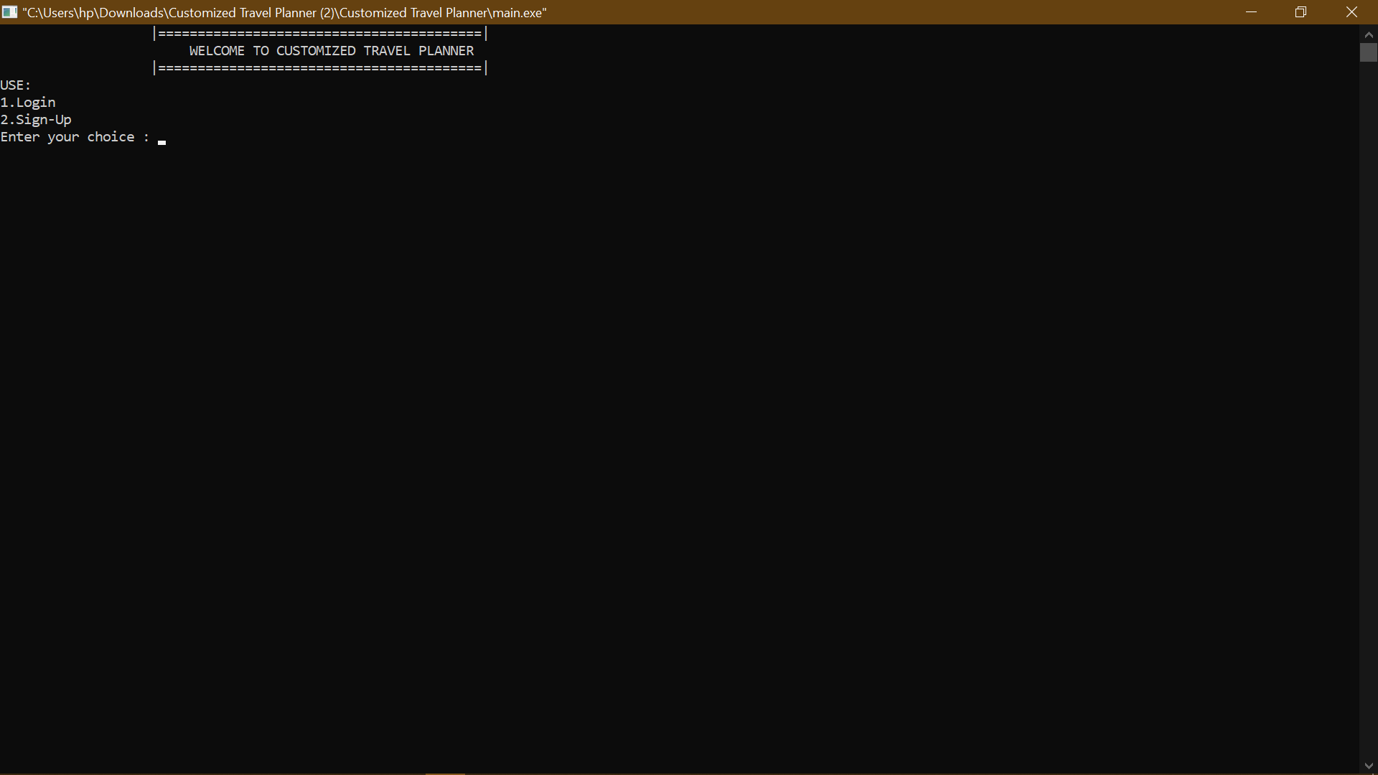

* SIGN-UP SCREEN

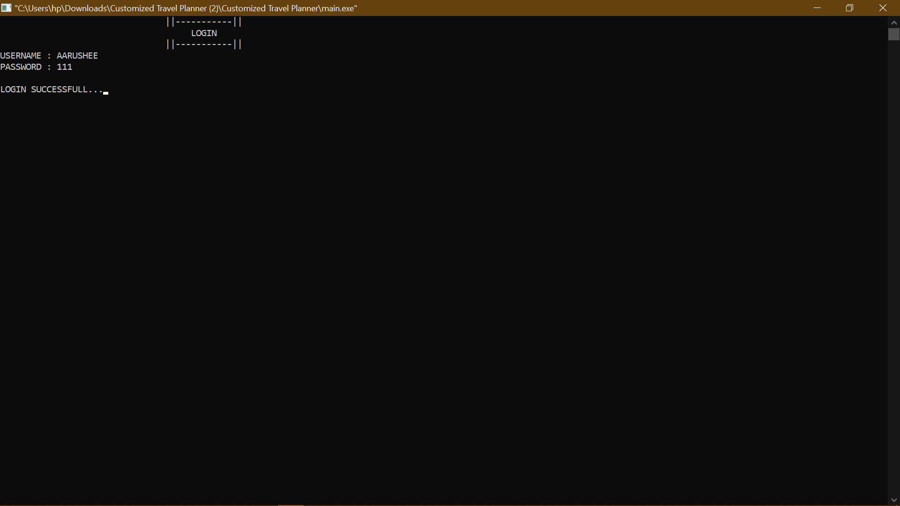

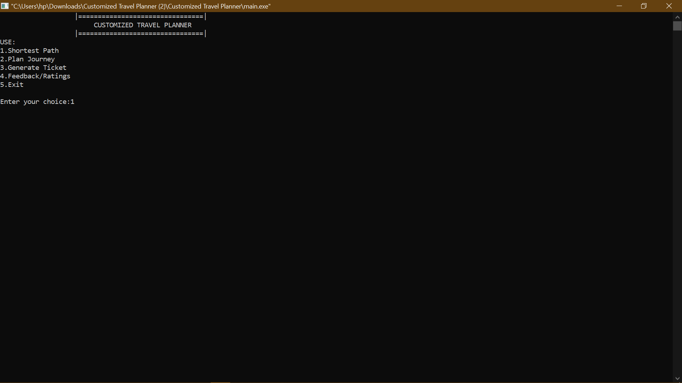

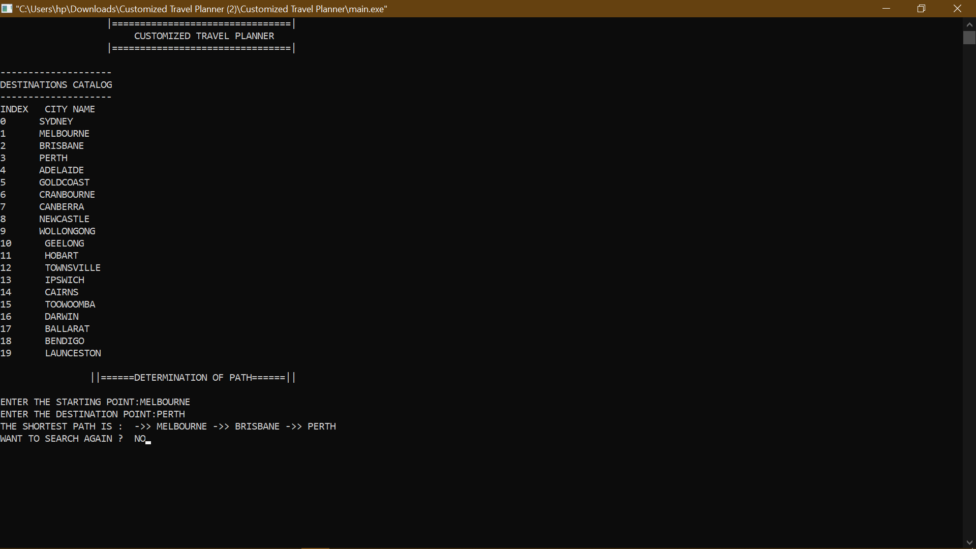

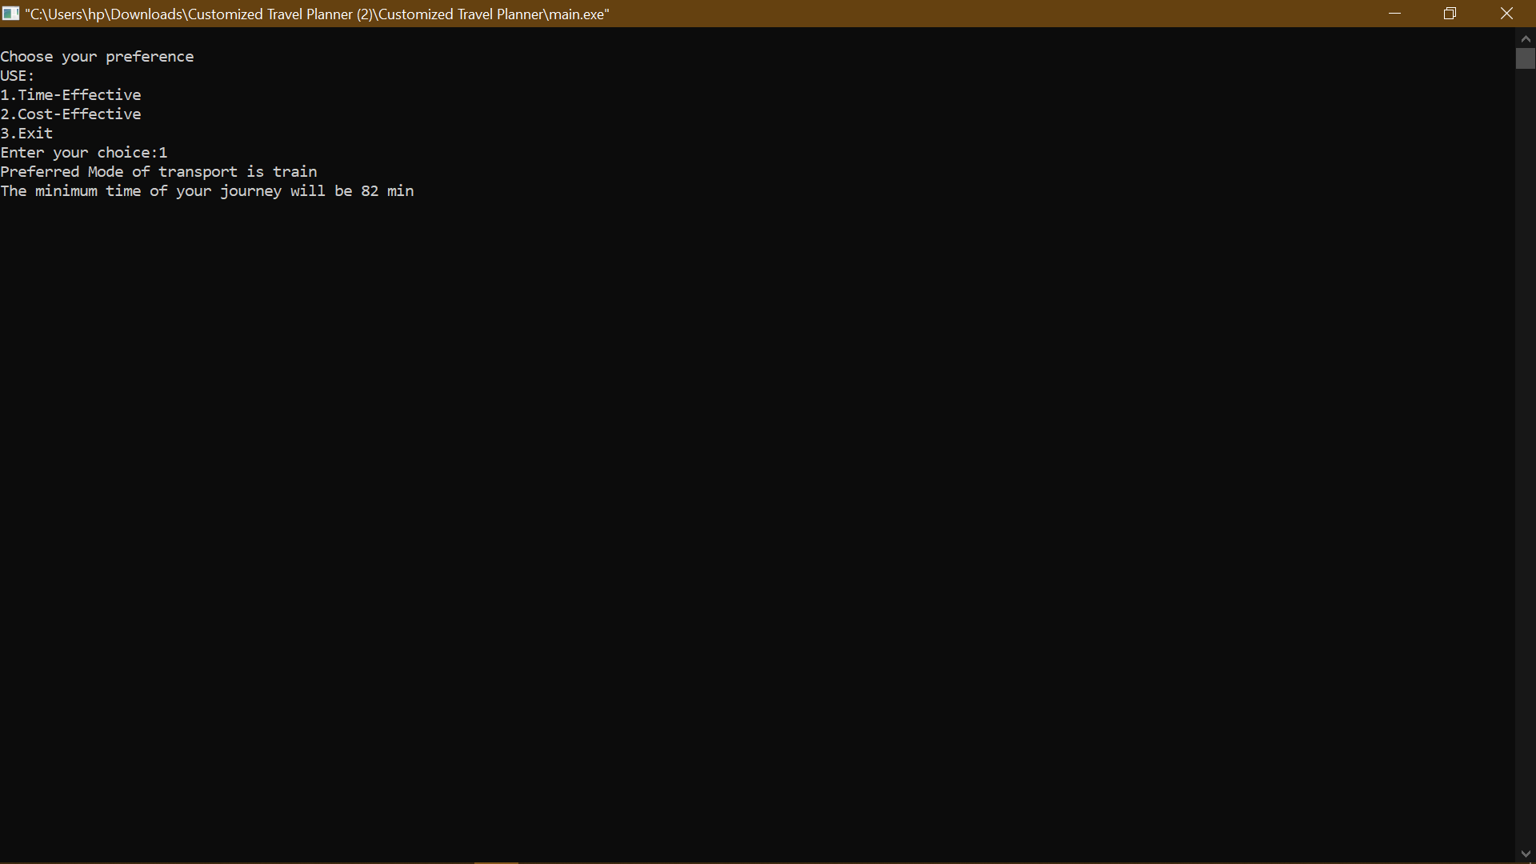

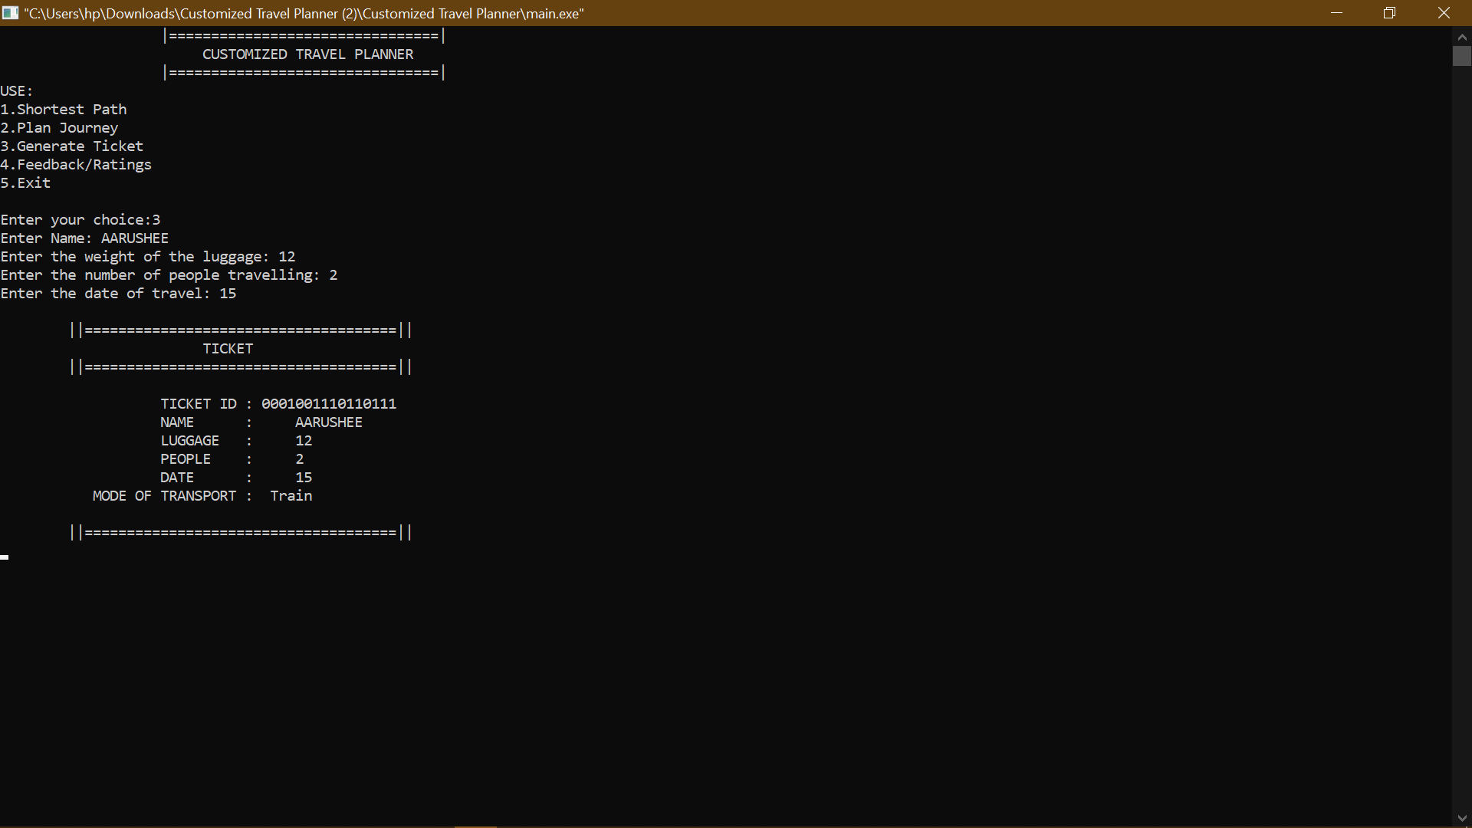

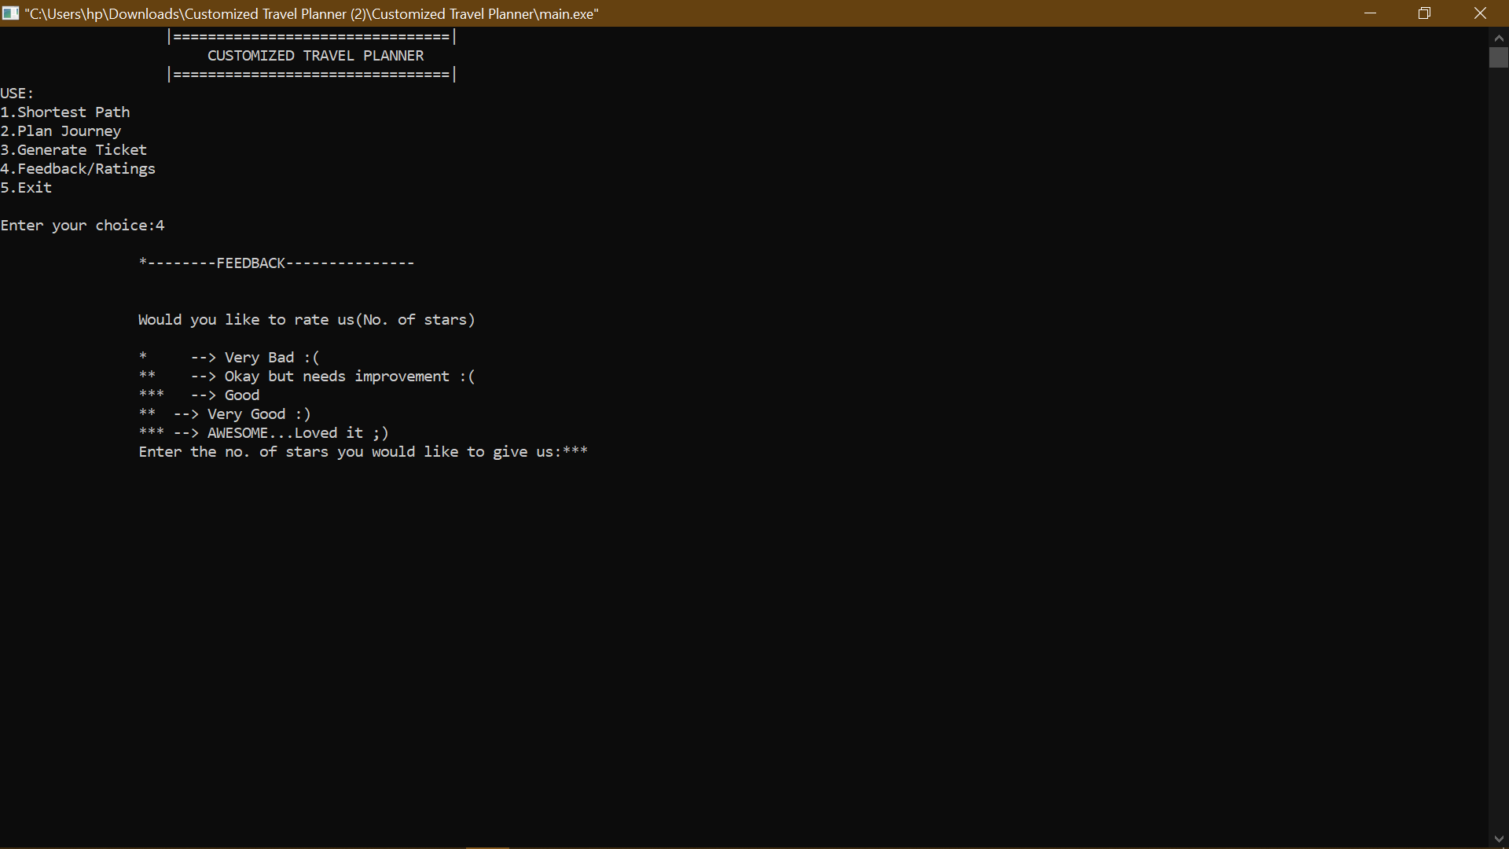

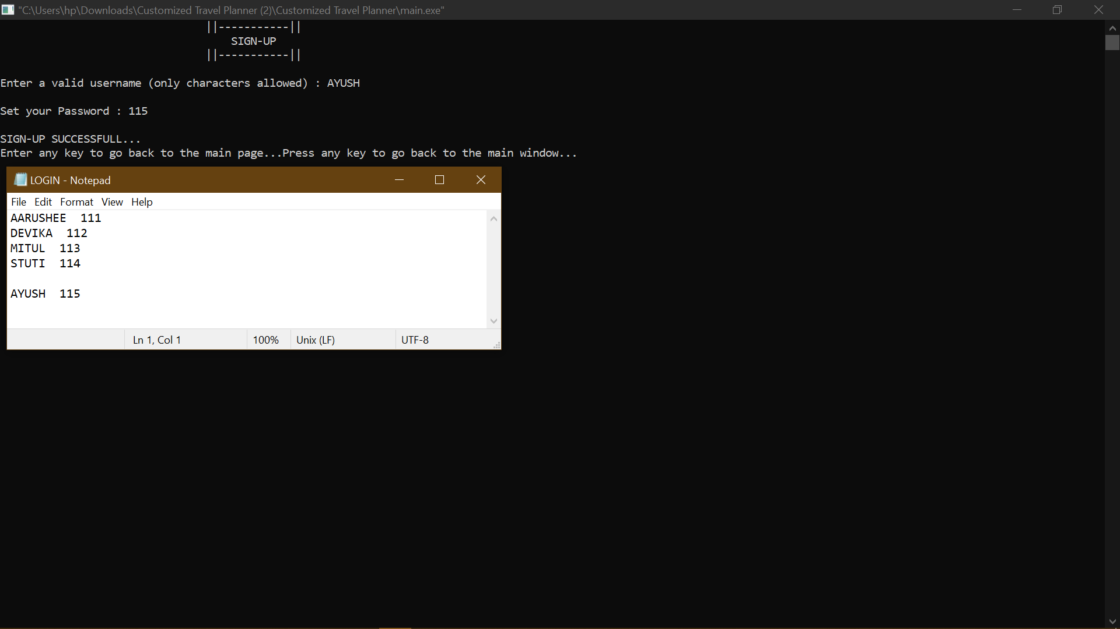

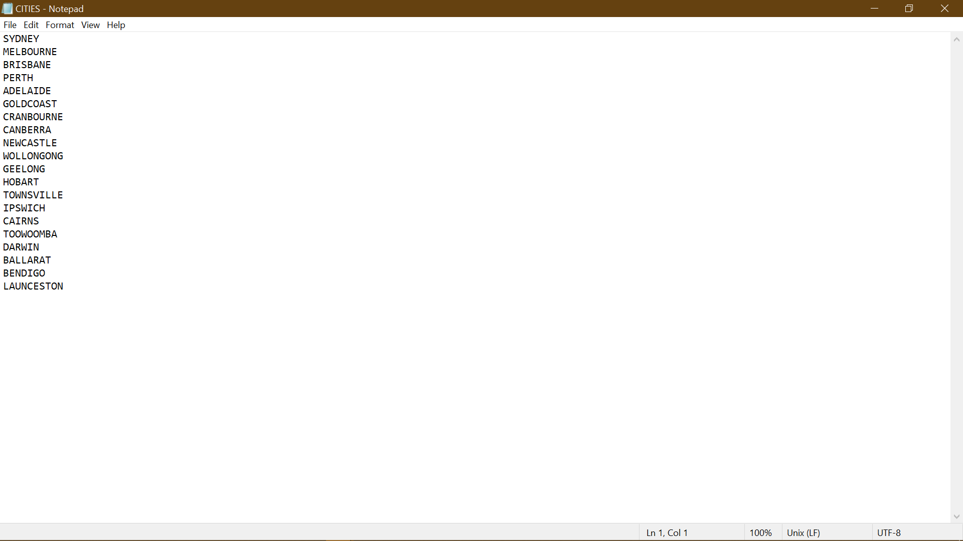

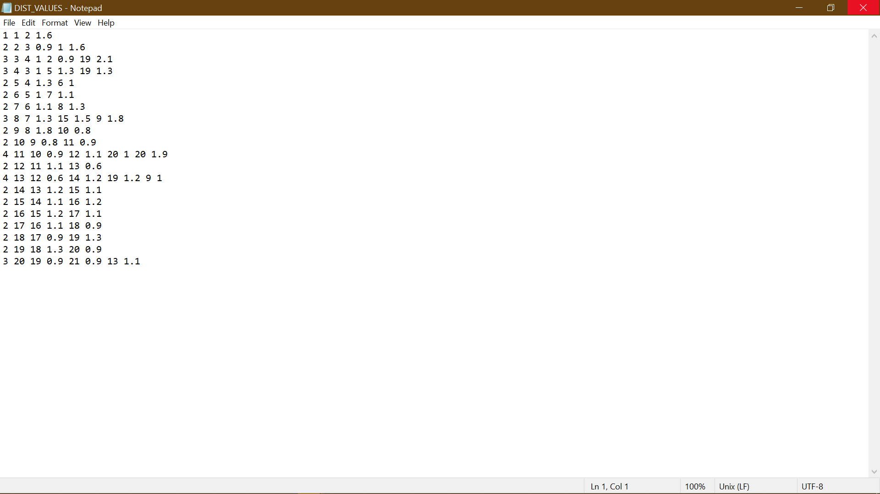

CONCLUSION

This project was developed for the Algorithm and Problem Solving Lab assignment. It was focused on using the most appropriate data structure and algorithm for a chosen real life-based problem scenario. While designing this Customized travel Planner System, we learnt and updated our project progressively. This project gave us essential exposure to solve simulating problems by debugging long codes. It also taught us teamwork, workmanship and leadership.

We are thankful to our teachers for providing this excellent opportunity to showcase our knowledge and apply it simulate a real-life concept.

**---------THANK YOU 😊--------**